Weekday breakfast
Served Monday thru Friday 9 am – 4 pm

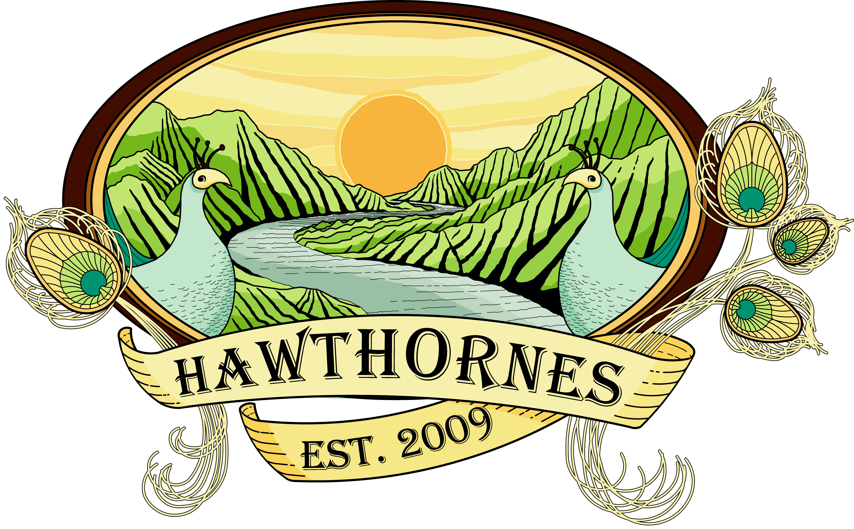

**Consuming raw or undercooked meats, poultry, seafood, shellfish or eggs may increase your risk of foodborne illness**
Hawthornes 738 S. 11th Street (corner of 11th & Fitzwater)
Tel: 215.627.3012 * www.hawthornecafe.com

Orange Juice $3.00
Milk $2.00
Hot Chocolate $2.00
Hot Tea $1.75
Chamomile, Mint, Green,
Regular, Decaf, Earl Grey,
English Breakfast

One Village Coffee
Fair trade, Organic and Local…aka roasty deliciousness!
French Press $3.00 per person * Drip $2.50 per person
Virgin Mary $12.00
BYOL and make it bloody!
32 oz of homemade spicy non-alcoholic bloody mary mix

EGGS
All egg dishes are made with extra large cage free brown eggs and served with
our rosemary homefries mixed with sautéed peppers and onions and multigrain toast.
Substitute homefries and toast for mixed fruit $1.50, Substitute for egg whites $1.25

Sides
One Egg $1.00, Two Eggs $2.00
Sausage, Bacon, Ham, Veggie Sausage $2.50
Fruit Salad Cup $3.00, Bowl $6.00
Homefries $2.50
One Pancake $3.00
Toast $1.50

Two Eggs Any Style $5.00
Add meat: house smoked thick slab bacon, ham steak, large link sausage, veggie sausage $7.50
Omelets $8.00 Each Additional Ingredient $1.00
Three eggs with your choice of three ingredients
Choose Three: Cheddar, Sharp Provolone, Goat Cheese, Tomato, Onion, Bell Pepper, Spinach, Mushrooms, Asparagus, Ham, Bacon
South of the Border Eggs $11.00
Two Crispy Flour Tortillas, topped with Two Over Easy Eggs, Black Bean Salsa, Spicy Ranchero, Cilantro Sour Cream & Scallion

One Eyed Willy $6.50
One Sunny Side Up Egg served on top of multigrain toast…Joined with a smiley face of bacon!
A Hot Potato Mess $8.00
A Whole Mess of Hawthornes delicious homefries mixed w/3 Eggs scrambled topped with sharp cheddar and fresh parsley. It’s certainly not the prettiest dish but one of the tastiest!
Juan’s Big Burrito $9.00
Two Eggs Scrambled with your choice of ingredients listed below wrapped in a flour tortilla
Served with a spicy ranchero sauce, avocado and our cilantro sour cream.
Choose from: Cheddar, Sharp Provolone, Tomato, Sautéed Onion, Bell Pepper, Spinach, Mushroom, Asparagus

HAWTHORNES’ SPECIALTIES
Hawthornes’ House Baked French Toast $8.00
Another Hawthornes original sure to warm the belly.
No Syrup Required, but Included ☺

Pancakes or Waffle $6.00
Three homemade fluffy Buttermilk Pancakes --or-- One Large Waffle
Add to either waffle or pancake: Swiss Chocolate Shavings, Bananas, Blueberries or Strawberries $1.00 ea
Yogurt Parfait $7.00
Non-Fat Organic Vanilla Yogurt, Mixed Seasonal Fruit, Vanilla Almond Granola drizzled with Organic Honey
BAGELS & BREAKFAST SANDWICHES
Four Worlds Traditional Jewish Water Bagels: Local, Organic, and Rolled with Hand Milled Flour
Choose from Everything, Poppy or Plain Toasted with choice of…
Just a Bagel $2.50
Organic Raspberry Preserves $3.00
Cream Cheese $3.25
Cream Cheese & Organic Raspberry Preserves $3.50
Egg and cheese (served with homefries) $6.50
Egg, meat and cheese (served with homefries) $8.50
Captain Ahab: Cream cheese, fresh smoked salmon, spring mix, red onion, tomato and capers $9.00

S.O.S. $9.00
Our homemade take on the Pennsylvania Dutch original…
Creamed chipped beef served over toast

